**GRAVITYSTACK & HERETIK DEMO/MEETING ROOMS**

**Estimate:** $3,000/ROOM (including reservation, food & drink, and swag)

**Purpose:** Client & Prospect Demos

**Opportunity:** Each respective room will be focused on showcasing products, educating clients/prospects, and identifying opportunities.

* This block of rooms should be as unique and impressive as our products. People should naturally be drawn to these rooms, and find themselves hanging out naturally (good food, drinks, swag, décor, and presentations)
* Rooms will be uniquely branded to each company
* Meeting schedule should be set as much as possible ahead of time to best coordinate with the content creation room

A picture containing indoor, table, wall


**A living room filled with furniture and a flat screen tv

**

A display in a room


**CONTENT/MEDIA ROOM­­­­**

**Estimate:** $3,000* (including reservations, swag, food & drink)

\**The real ‘cost’ here is Sarah’s time behind the camera and video editing.*

**Purpose:** Content creation & relationship building

**Opportunity:** Clients are looking for content around their new technology. Our ‘Content Creation’ room is an opportunity for them to get some quick, easy, and effortless content around their time at LegalWeek, while also opening the door for other co-creation/content opportunities. Having a third-party facilitator helps validate the content and removes the ‘agenda’ of Heretik/GravityStack.

* This room will be used for filming video interviews, podcasts, and/or articles with clients, prospects, or our own teams
* Room should be ‘worth stopping for’
* Some interviews/topics can be scheduled ahead of time with corresponding client meetings
* Room & branding should be neutral and interchangeable for production
* Sarah (video & editing) and Zach (interviewing and publishing) will be primary content creators.
* We have all necessary video equipment, which is biggest expense

**A close up of furniture

**

**LEGALWEEK PARTY**

**Estimate:** $

**Purpose:** Relationship building & brand awareness

**Opportunity:**

**Invitation Idea:** Door hangers?

A screenshot of a cell phone


**48 Lounge**

Premium Open Bar

300 People x 3 HRS (+20% tip) = **$25,200 (not including tax)**

Pre-Selected Open Bar

300 People x 3 HRS (+20% tip) **- $21,600 (not including tax)**

Butler Passed Hors D’Oeuvres  
($7 items/per 1.5 hours) **$2,100**

**Pros:**

* Options for different areas, including a smaller VIP room.
* Food/hors d’oeuvres available.

**Cons:**

* Might not be able to accommodate 200 guests, or otherwise rent out the entire venue.
* Would have to go somewhere else for dinner.

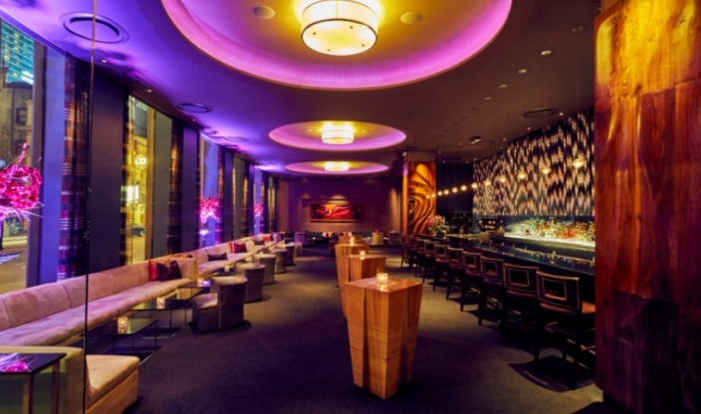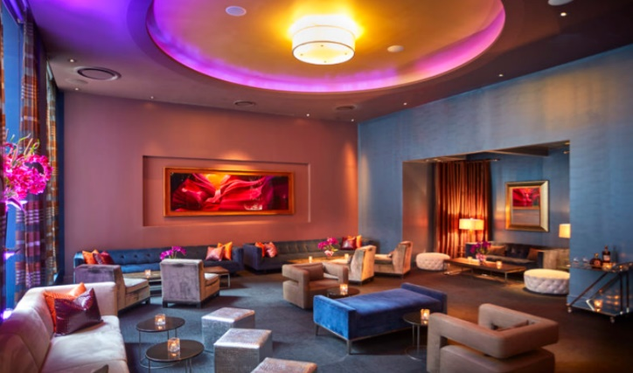

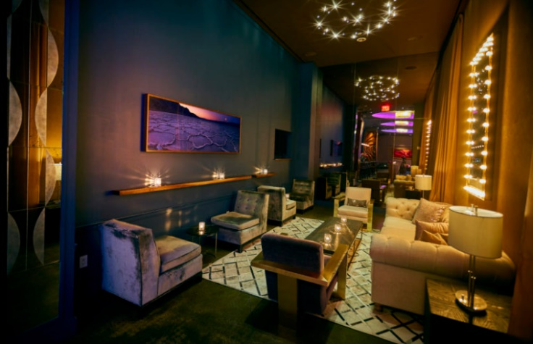

**Lavo Lounge & Italian Restaurant**

**Pros:**

* Sharri approved and recommended
* Has restaurant and night club options
* Wouldn’t have to go anywhere else for the parties
* VIP group of 30-40 could be placed in restaurant

**Cons:**

* Might be more on the expensive side
* Service seems to be split among reviews

**Premium Open Bar**

300 People x 3 HRS (+20% tip + 24% admin fee)= **$32,400 (not including tax)**

**200 people = $21,720**

**Restaurant (2.5 hours each):** $75 per person plus tax, 5% fee and tip  
or $100 per person plus tax, 5% fee and tip

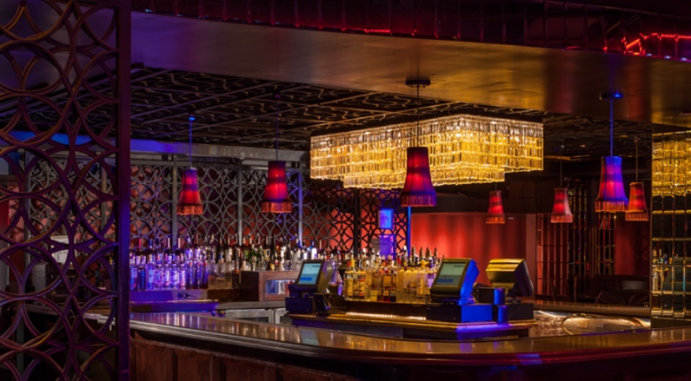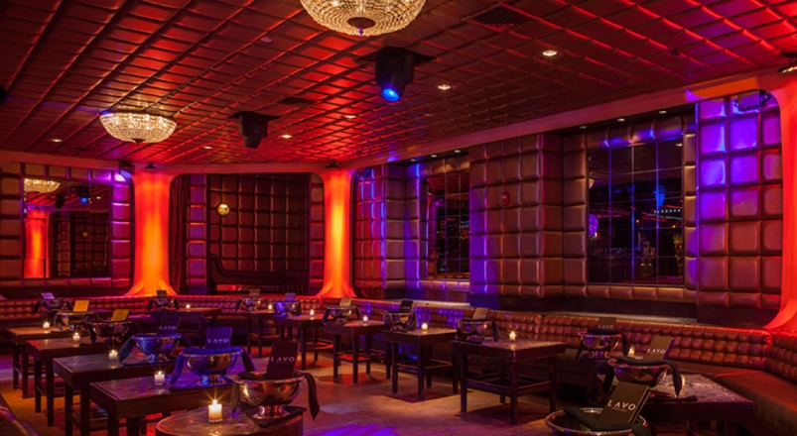

**The Roof Lounge & Kingside Restaurant**

**Pros:**

* Nice interior, sophisticated
* Could be used for a VIP/smaller party
* Hors d’oeuvres options, restaurant downstairs
* Indoor and covered

**Cons:**

* Capacity of 100 guests for both the Roof lounge and Kingside dining.
* Private dining room for Kingside (40 guests).

**\*\*\* WAITING ON PRICING**

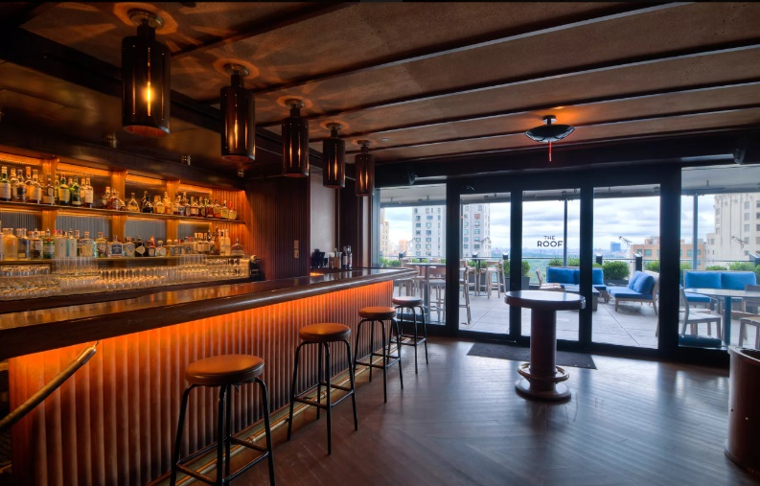**The Roof**

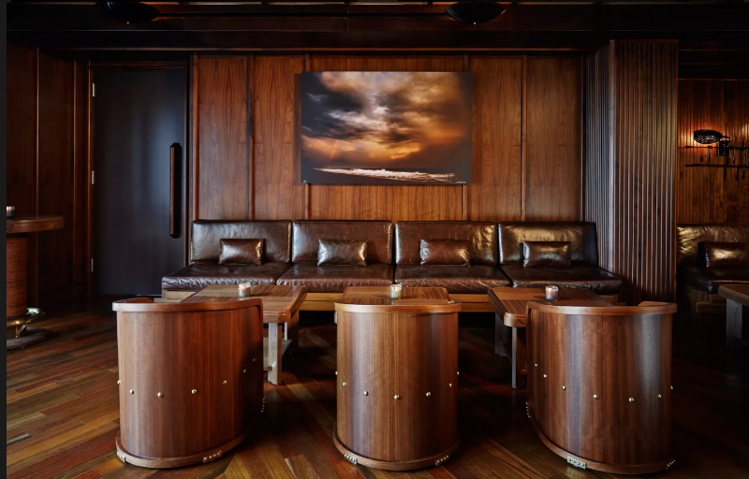

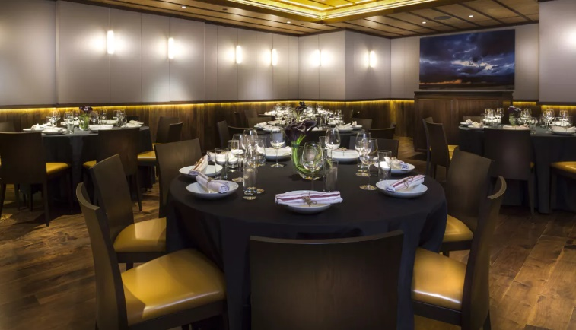**Kingside Private Dining Room**

